**Pizza Sales Analysis Summary**

* **Total Revenue**: Out let is generating $87,860 in a year.
* **Highest Sales by Pizza Size**: Large-size pizzas generate the highest revenue, while XL pizzas have the lowest price among all sizes.
* **Top 5 Most Ordered Pizza Types**: *Big Meat S* is the most ordered pizza overall.
* **Category-wise Quantity and Share**: Classic pizzas hold the largest market share by quantity sold.
* **Order Distribution by Hour**: Evening shifts experience peak orders, while mornings have minimal traffic.
* **Category-wise Price vs. Quantity**: Supreme pizzas have the highest unit price, but Veggie pizzas sell more units than Supreme pizzas.
* **Monthly and Daily Peak Sales**: July has the highest monthly sales; on a daily basis, 27th November recorded the most orders.
* **Top 3 Revenue-Generating Pizzas**: Thai Chicken pizzas lead in revenue, followed by Barbeque Chicken pizzas.
* **Veg vs. Non-Veg Sales**: Customers prefer non-vegetarian pizzas over vegetarian options.

**Suggestion:**

**Increase Large Pizza Promotions**

* Since large-size pizzas generate the highest revenue, introduce combo deals and family meal offers to further boost sales.
* Highlight large pizzas in marketing campaigns during weekends and evenings.

**Capitalize on Best-Selling Pizza Types**

* Big Meat S is the most ordered pizza — introduce limited-time variations or bundle offers with drinks/sides to maximize profit from its popularity.

**Seasonal & Date-Based Marketing**

* July is the top month — plan **big seasonal campaigns** around that time to further boost revenue.
* On 27th November (historically busiest day), run a **“Pizza Festival Day”** with flash deals to maximize orders.

Codes:

* Total Revenue generated from pizzas sales.

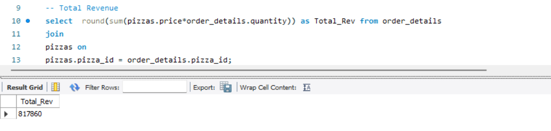

* Which pizzas size is generating highest sales.

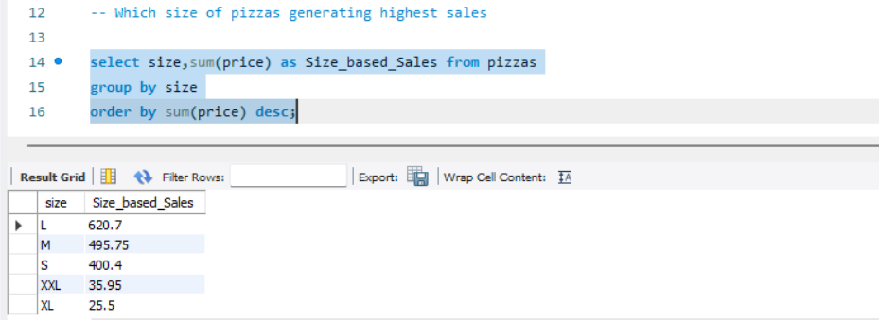

* top 5 most ordered pizza types

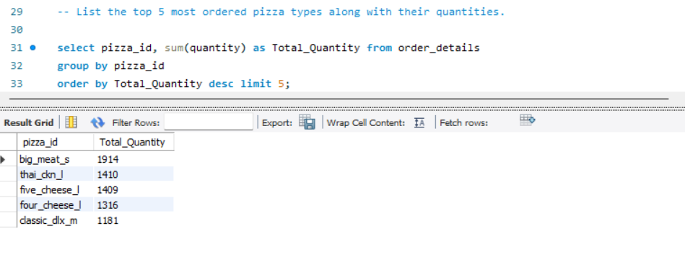

* Total quantity of each pizza category and share

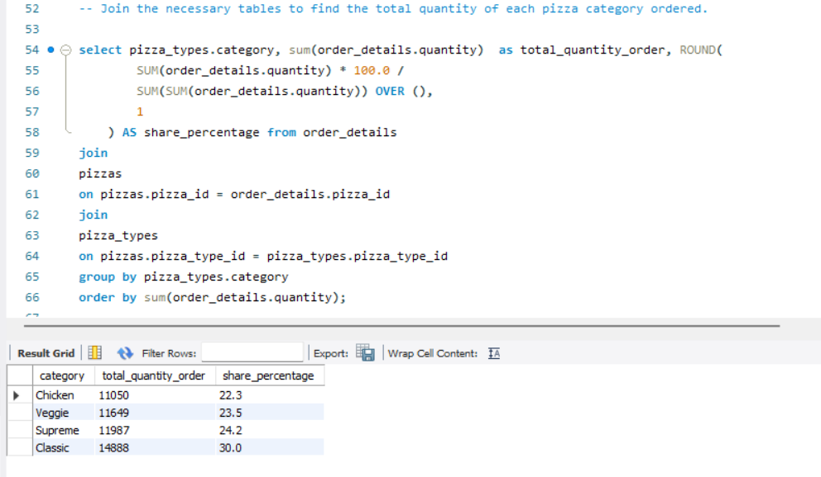

* Determine the distribution of orders by hour of the day.

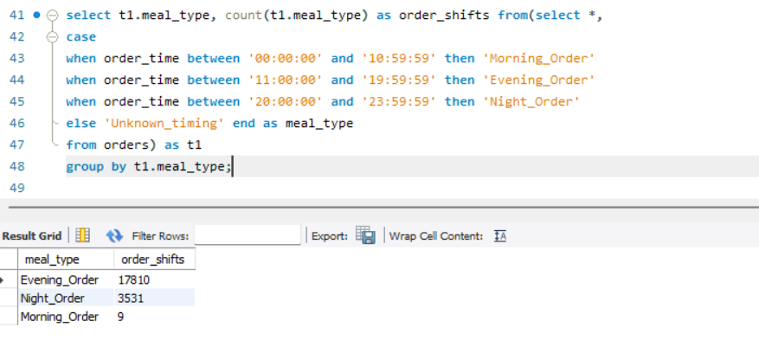

* Total number of orders

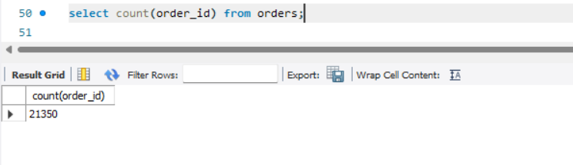

* Join relevant tables to find the category-wise distribution of pizzas.

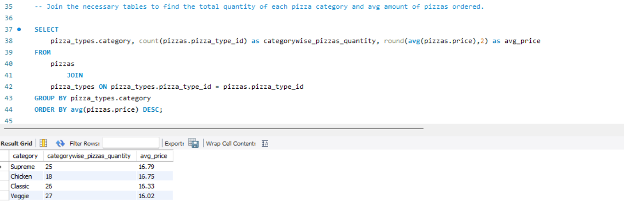

* highest sales on a which day of a year and month wise sales distribution.

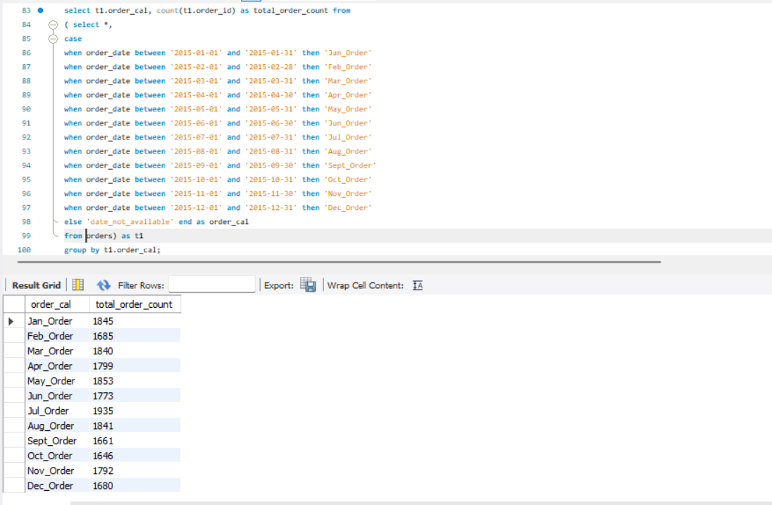

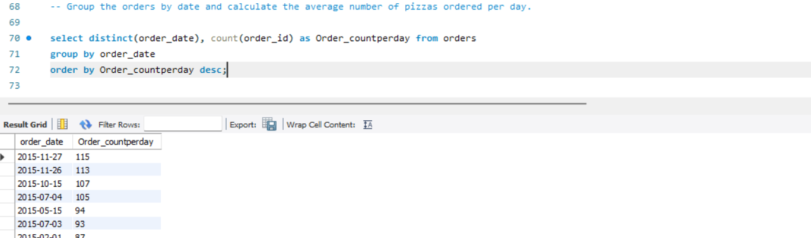

* top 3 most ordered pizzas based on revenue

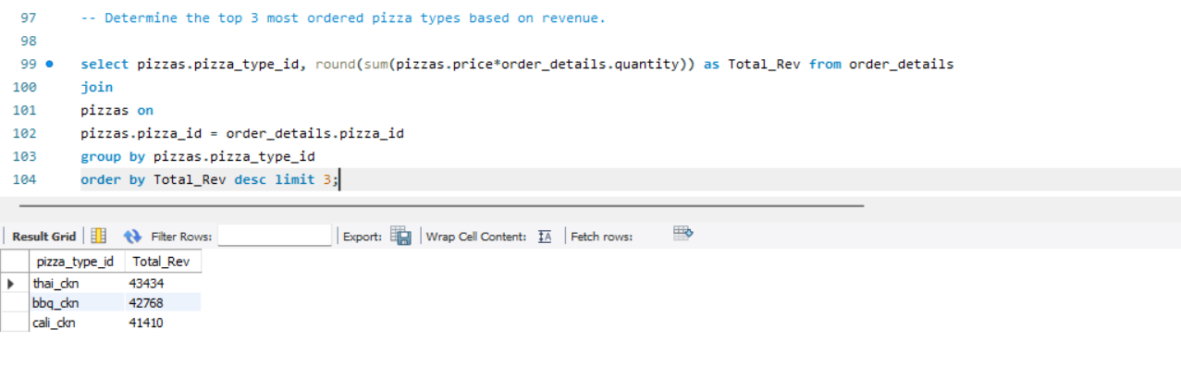

* Total revenue generated based on food type: Veg or Non-Veg

